How to use Microsoft Teams
You can either download the Microsoft Teams app from the app store on your device

Or you can use the web browser by going to https://www.microsoft.com/en-gb/microsoft-365/microsoft-teams/group-chat-software

Please DON’T CREATE AN ACCOUNT – your child already has login details.
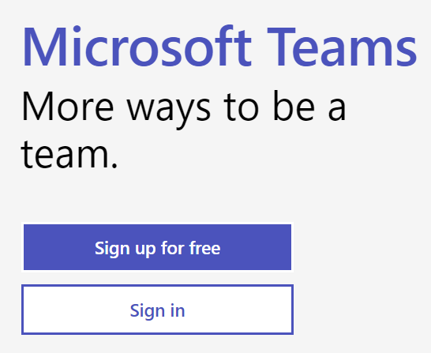
Click sign in.

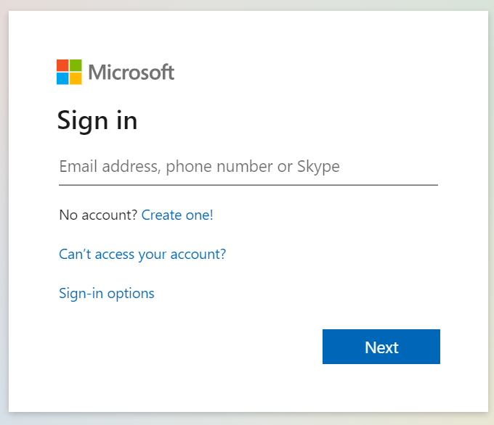
You will then be taken to this screen – this is where your child can login using the details we have set up for them.
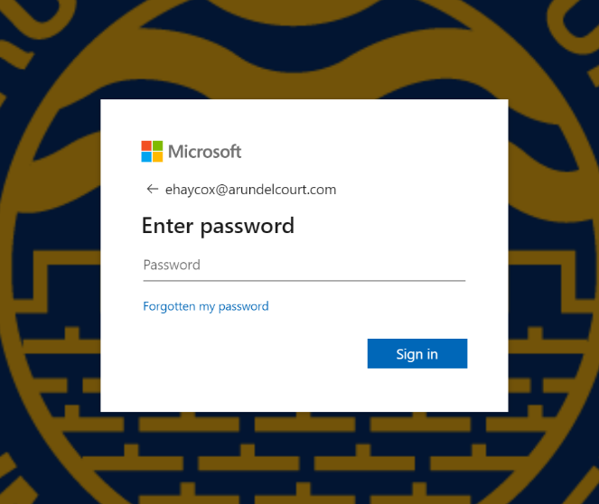
Once you have logged in click on Teams and you should be taken to a screen that looks like this:
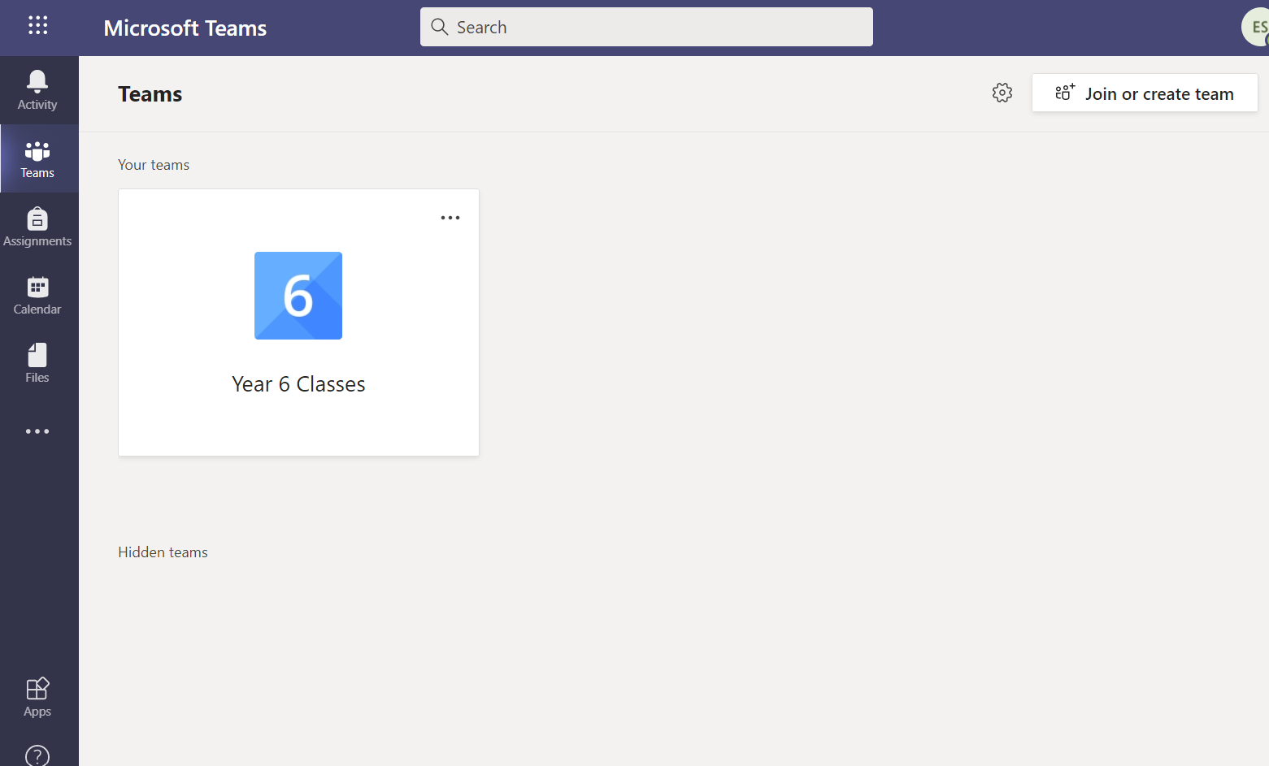
Click on Year 6 Classes
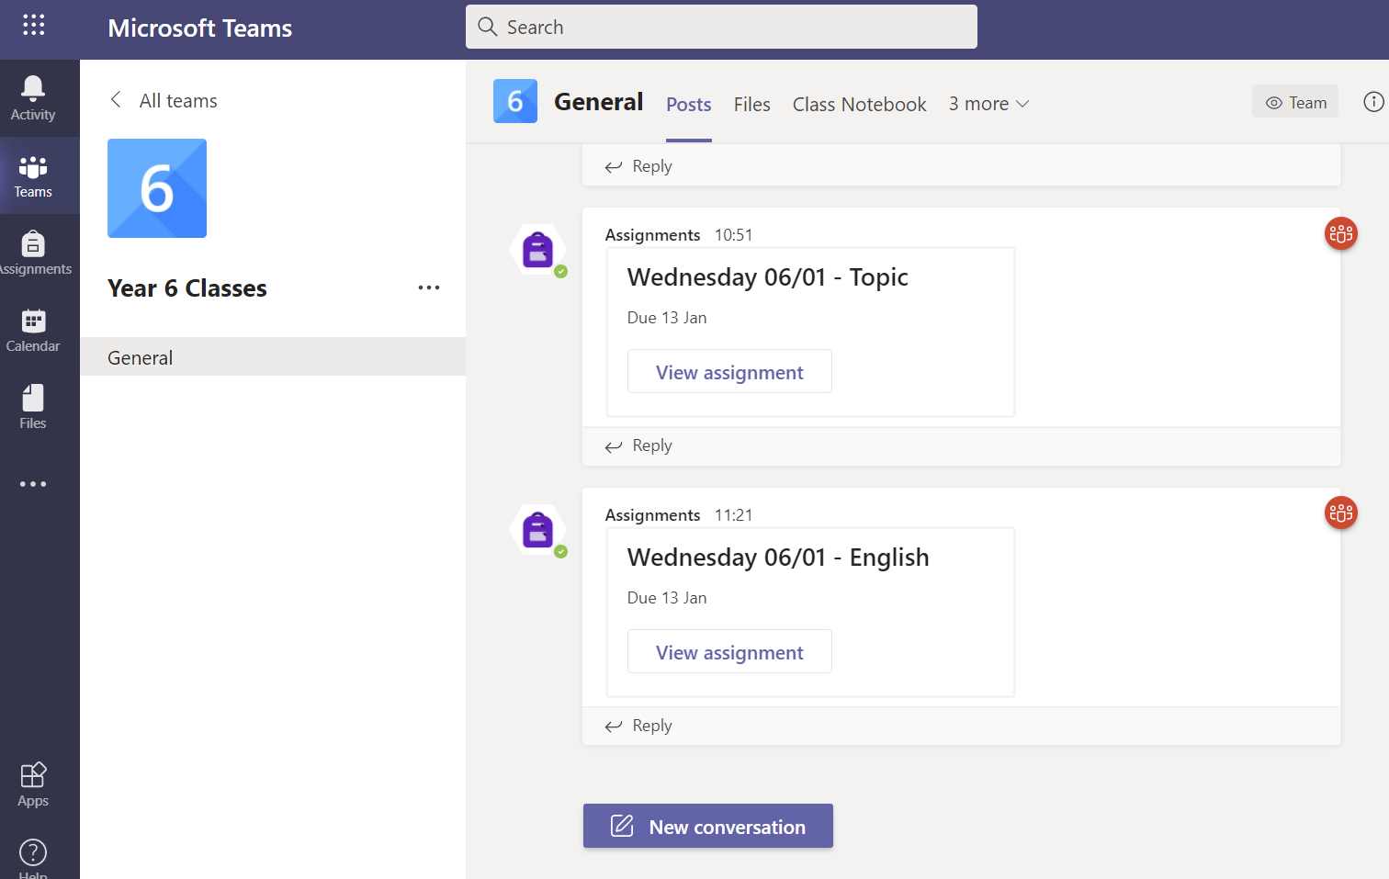
At the top of your screen you will see some tabs. The only ones you will need are:
Files – this is where you can see information uploaded by teachers.
Assignments – this where you can have a go at completing some worksheets.
The Files screen will look like this:
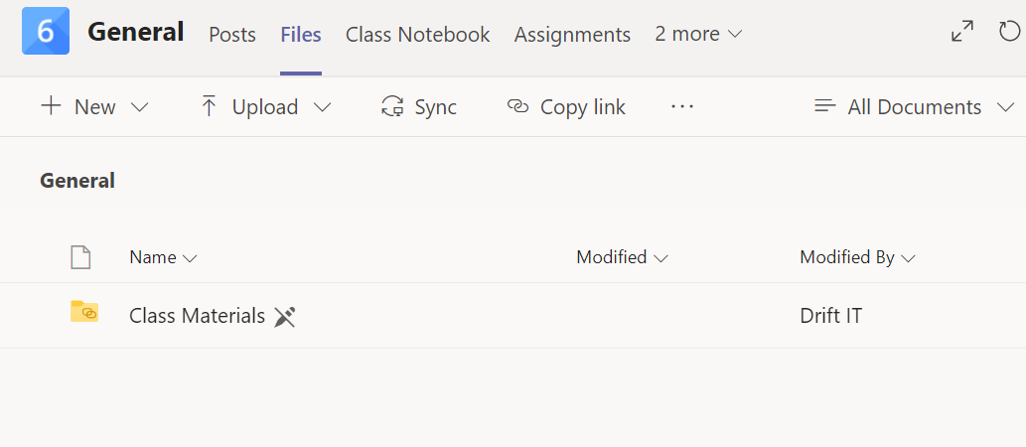
If you click on Class Materials, this will have a welcome document at first, but more documents will be added here when necessary.
The Files screen will also be where you to watch the video lessons we will have recorded.
The Assignments screen will look like this:
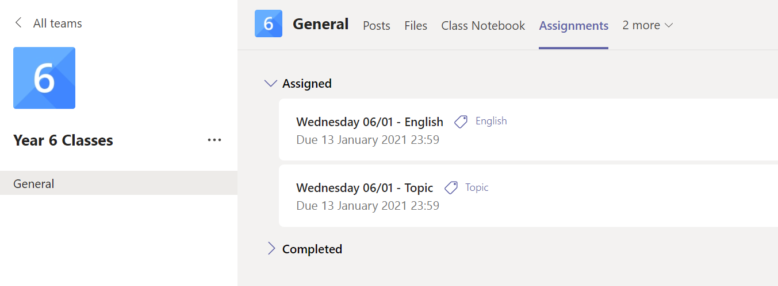
You can then click on the assignment you need to complete and it will open a screen similar to this one:

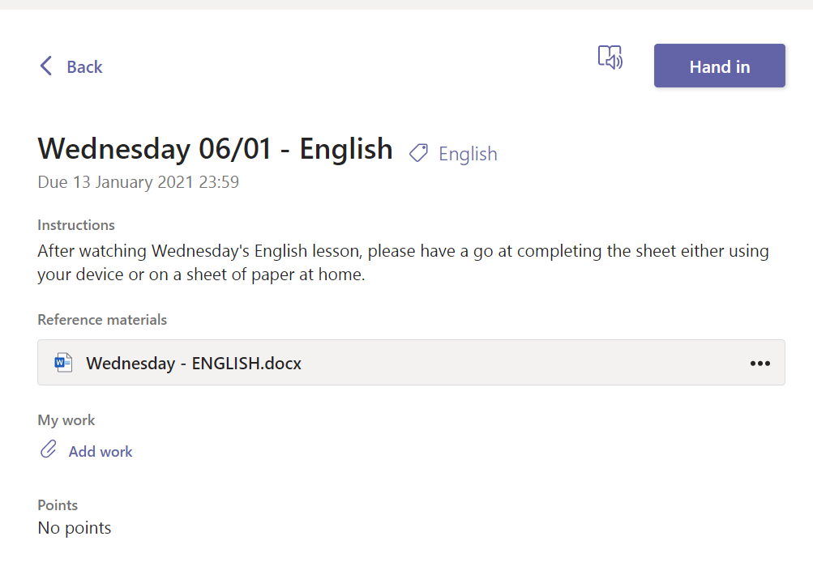
Click on the document to complete the worksheets. Anything you type is saved automatically. Once you have completed the work click close.
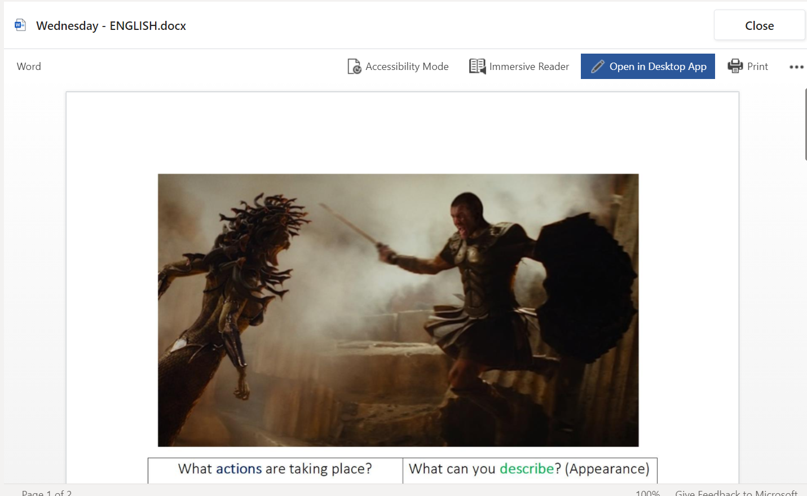
You will then go back to this screen where you need to click Hand in – this will let a teacher know that you have completed it.

We will be on hand to help you if you have any issues – please email year6@arundelcourt.com

