

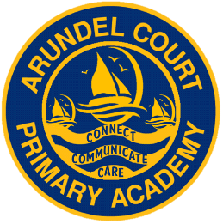

*[](http://www.investorsinpeople.co.uk/)*

**Teaching and Learning Policy**

**Covid Update 20/07/2020**

**Curriculum Statement**

Underpinning our curriculum is our strong school ethos which is developed through our whole school values. We offer children an education in a safe, happy and nurturing environment.

**Intent:**

Our curriculum is driven and designed to meet the needs of our unique community. It is passionately felt by all members of staff that the curriculum is delivered through first-hand experiences of the real world and the children understand that there is ‘Life beyond Landport’.

We aim to provide a curriculum which opens up doorways and opportunities, our children need to develop the life skills required to become successful and to develop a love of learning.

At Arundel Court Primary Academy, we broadly follow the National Curriculum; its design ensures the breadth of knowledge is delivered in an awe-inspiring and memorable way.

Our children are immersed in a curriculum which allows them to explore, discover and dream.

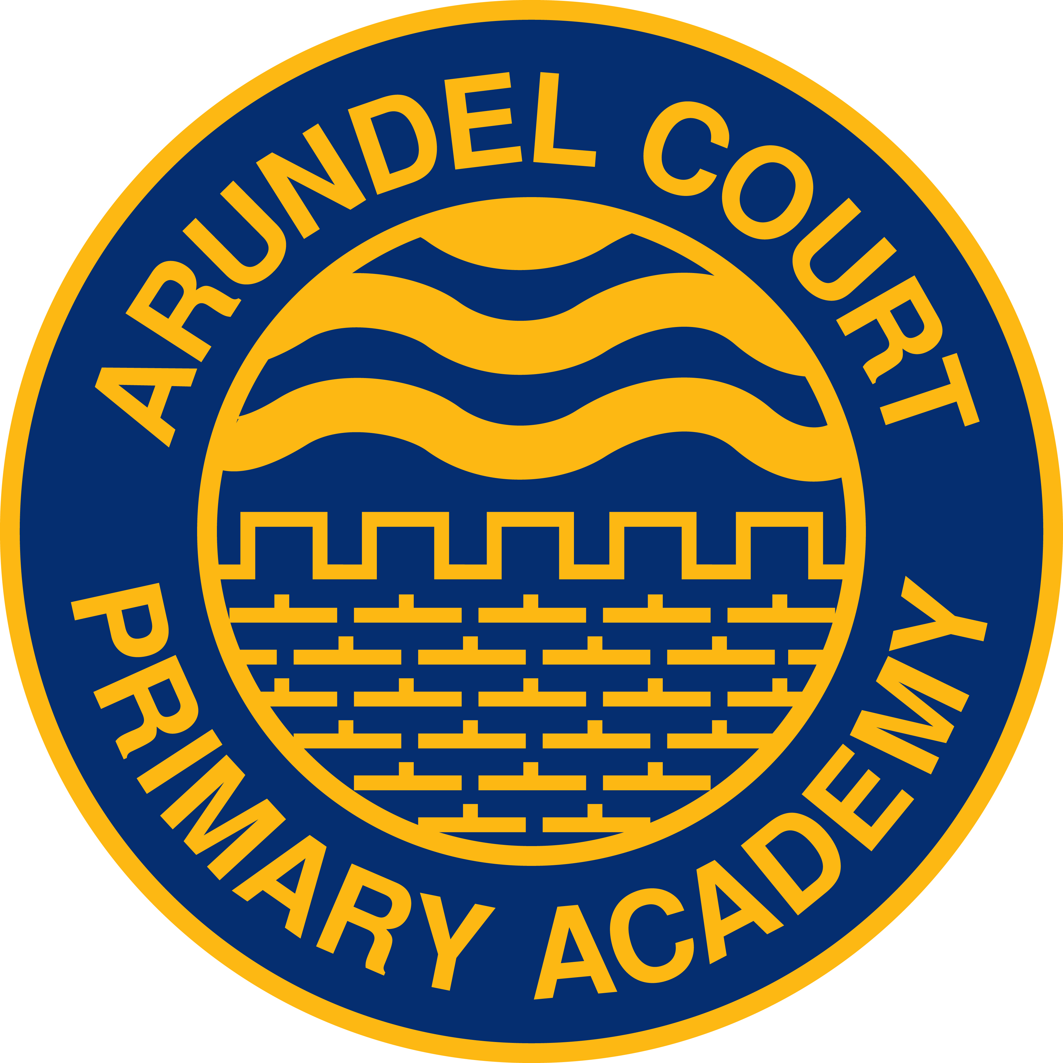

**Key Principles**

*Our aim is for pupils to leave Arundel Court…*

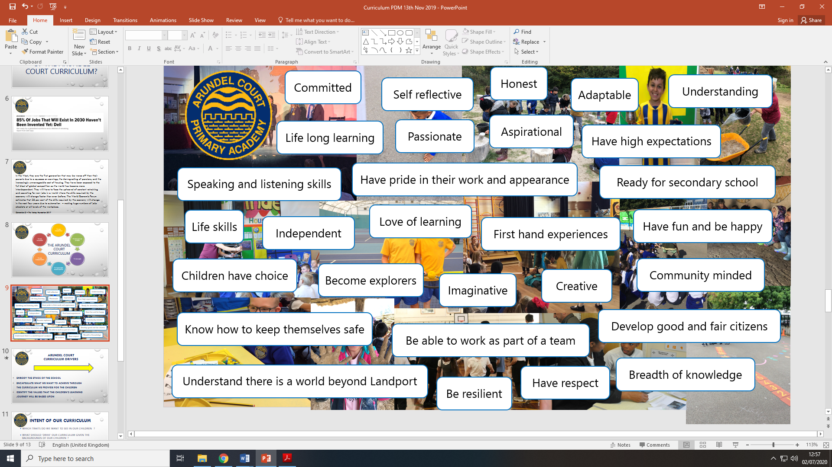

* The curriculum is implemented in a purposeful way and takes into account the individual needs of our children.
* Through high quality teaching of knowledge, skills and vocabulary across core and foundation subjects, all children are challenged to be creative, resilient, independent and aspirational learners.
* Children are ‘hooked’ into their learning via well planned imaginative and creative experiences.
* The outcomes are celebrated through assemblies, presentations and learning journeys.
* To develop the children’s understanding of a ‘Life beyond Landport’ the Arundel Court ’50 things’ should allow the children to explore and experience the curriculum beyond our community. This can be achieved independently, through our own curriculum or through a wide range of extra-curricular activities which are available to all children.

**Planning**

**At Arundel Court we have three forms of planning**

1.**Long term plans:** This plan gives an overview of the topics that are covered through the course of the year. This plan includes the hooks and outcomes for each topic taught and possible trips and visits.

2.**Medium term plans:** This is a half termly plan which is also shared with parents in the form of a curriculum newsletter. There are also medium term plans written by subject leaders which indicate when learning activities will be taught in the half term and show progression of the knowledge and skills.

3.**Short term plans:** These are daily plans for core subjects. For our foundation subjects staff use the medium term plan to either create a weekly plan or a daily flipchart.

**Marking**

Throughout the pupil’s books you may see a variety of marking and feedback which is appropriate to the task and individual child.

**All work completed by the children will be dated (adults/child) and initialled by an adult.**

**Early years:**

* Tapestry is used to evidence the learning journey of the children
* Written comments stickers, L.O and S.C can be used for English and Maths
* Next steps identified by adults
* In the summer term corrections in spelling and handwriting where appropriate

**Year 1:**

* Tapestry is used to evidence the learning journey of the children
* Use DWP (discussed with pupil) with word showing what was discussed *e.g. capital letters* and any other evidenced based comments
* Will introduce ‘WOW’ and ‘NOW’ where appropriate
* Symbols used as feedback marking in writing only
* A poster of the marking symbols with definitions on how to use them are available and must be displayed in all year 1 classes

**G.W - Guided Work**

**I - Independent work**

**G.W - I Started Guided and went on to complete independently**

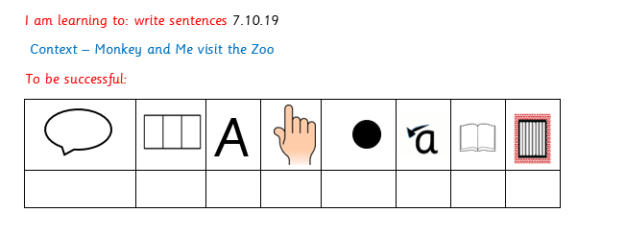

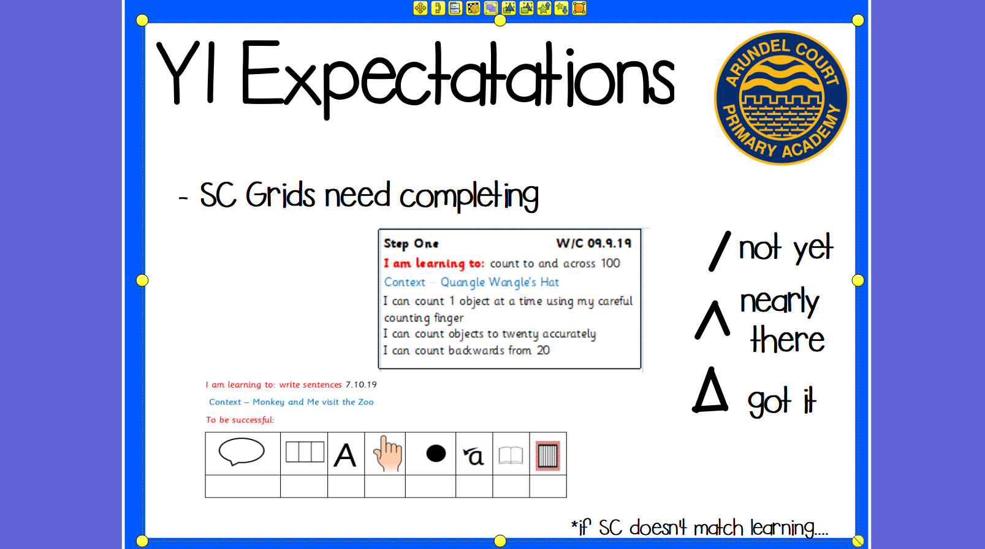

**Year 2- Year 6:**

* Use observational comments
* **Green for Great, Pink for Think** e.g. ‘Wow’ and ‘Now’….
* **Pink for Think** could include (e.g.):
  + - * a next step
      * now try this
      * a challenge
      * a reinforcement
      * addressing a misconception.
      * Letter and number formation corrections and handwriting and spelling errors in Year 2 only
* Topic books in KS2 will receive a comment at the end and ongoing marking when appropriate.
* **Secretarial marking in all curriculum areas:**
  + **Orange highlighter** (introduced in Year 3) used for ‘nagging’ punctuation and spelling with the child correcting spelling or punctuation error depending on the child’s needs.
  + **Purple Polishing Pen -** Children to self-correct and edit with a purple pen.
* **Success Criteria:**
  + **Teacher/TA** to complete theSC grid when used and when appropriate.
  + **Children** are encouraged to assess their learning.
* **DWP** (Discussed With Pupil)
  + Use DWP (discussed with pupil) with **word** showing what was discussed e.g. capital letters.
* **Photo evidence (in line with GDPR regulations):**
  + To have a comment to explain the image used.
* **Immediate Intervention** recorded, dated and initialled in Maths and English books by TA.

Please see below notes related to Covid-19 regarding marking.

|  |  |
| --- | --- |
| **Marking** | **Action Required** |
| Providing on the spot feedback (DWP) | Staff and children must position themselves side by side. |
| Marking books | Books and equipment must be wiped down and hand washing hygiene systems must be followed. |

**Assessment and Monitoring**

We use OTrack (online programmes) to track children’s progress and attainment throughout the year. The Trust have designated termly ‘data drop’ dates. The school has an assessment and monitoring schedule which is followed by all leaders of learning.

**GAPs**

Targeted children are conferenced on a regular basis. They are given quality, one to one, time with the teachers to look at what they are doing well at in writing. From there they are set up to three very specific targets which are revisited in two weeks’ time. This goes on as long as the child needs it.

**Statutory Assessment Points**

**Early Years:** At the end of Early Years (end of year R)the school is measured by assessing what percentage of the children achieved a Good Level of Development **(GLD)** and this is compared to national percentages as well as Portsmouth percentages.

**Year 1 Phonics Screening:** Towards the end of year 1, all year 1 children across the country have to take a test to see how good their phonics knowledge is. The test is out of 40 and to pass they need to achieve 32 and above. This is compared to national percentages as well as Portsmouth percentages.

**Year 2 Phonics Screening:**Children who did not pass the phonics test at the end of year 1 have to re-sit it again towards the end of year 2.

**Year 2 SATS:** Towards the end of year 2, all year 2 children across the country have to take a test in Reading & Maths. The results are compared to national percentages as well as Portsmouth percentages. Writing assessments are completed throughout the year.

**Year 4:** In the future, all year 4 children across the country will take a test in the times tables.

**Year 6 SATS:** Towards the end of year 6, all year 6 children across the country have to take a test in Reading, Maths and Spelling, Punctuation & ​​​​​​​Grammar (SPAG). The results are compared to national percentages as well as Portsmouth percentages. Writing assessments are completed throughout the year.

**Classroom Environment**

* A neat, safe and tidy, yet purposeful, learning environment.
* Appropriately stored and clearly labelled resources that allow children to develop independence in resourcing their own learning.
* Displays which support learning and accessible by the children from their chair. E.g. English and Maths working wall and the celebration of children’s work.
* At KS2
  + Evidence of rewards gained by our pupils through team House Points.
* At KS 1 and early years
* Our Golden Rules and behaviour management systems clearly displayed.
* Our values with all staff and children signing up to them are displayed.
* A bright and inviting book area.
* An environment that is conducive to learning e.g. a fantastic role play area in EY & KS1 or a bright and attractive area which supports the topic being taught.
* Purposeful and inviting outdoor provision for Early Years and Year 1.

**Home Learning**

Following DfE guidelines home learning should be planned in order to support our catch up/blended learning programme for children.

* **Early Years and Year 1**:
  + Reading regularly.
  + Tricky words and topic based words.
  + Maths e.g. number bonds.
  + Project based work (4-6 weeks).

Projects could cover a range of subjects and will be structured so there is a weekly activity for the children to complete at home. This may include pre-teaching, digital learning, hands on activities etc.

* **Year 2 to Year 6**
  + Reading at least 3 times a week and complete home reader.
  + Spelling.
  + Timetables work.
  + Project based work (4-6 weeks).

Projects could cover a range of subjects and be structured so there is a weekly activity for the children to complete. This may include pre-teaching, digital learning, hands on activities etc.

**Report to Parents**

* Reports to be sent to parents in:
  + April: a short report focusing on English and Maths and an overall comment.
  + July: a detailed report focusing on all subjects.
* Year 1 to report on Phonics screening
* Year 2 and Year 6 to report End of Key Stage SAT results.
* Nursery will complete transfer documents as per the LA schedule.

**Local Governing Body**

Our governors determine, support, monitor and review the school policies on teaching and learning.

In particular, they:

* Support the use of appropriate teaching strategies by allocating resources

effectively

* Ensure that the school buildings and premises are best used to support

successful teaching and learning

* Monitor teaching strategies in the light of health and safety regulations
* Monitor how effective teaching and learning strategies are in terms of raising pupil attainment;
* Ensure that staff development and performance management policies

promote good quality teaching;

* Monitor the effectiveness of the school’s teaching and learning policies

through the school self-review processes. These include reports from

subject leaders and the head teacher’s reports to governors.

**Role of Parents and Carers**

We believe that parents have a fundamental role to play in helping children to

learn.

We do all we can to inform parents about what and how their children are

learning by:

* Sending information to parents at the start of each term in which we outline

the topics that the children will be studying during that term at school (Curriculum News)

* Holding termly parents’ evenings to discuss their children’s progress
* Sending two annual reports to parents in which we explain the progress made by each child and indicate how the child can improve further explaining to parents how they can support their children with homework.

We believe that parents have the responsibility to support their children and the school in implementing school policies.

**We would like parents to:**

* Ensure that their child has the best attendance record possible (at least 95% and above)
* Ensure that their child is equipped for school with appropriate clothing and

correct PE kit.

* Do their best to keep their child healthy and fit to attend school
* Inform school if there are matters outside of school that are likely to affect a child’s performance or behaviour at school
* Promote a positive attitude towards school and learning in general.
* Support the school by signing up to the school’s values in our homes-school agreement.

Chair of Curriculum and Standards Committee: Dr S Smith

Chair of the Governing Body: Revd. C Hetherington

Date Agreed: Date for Review: July 2021