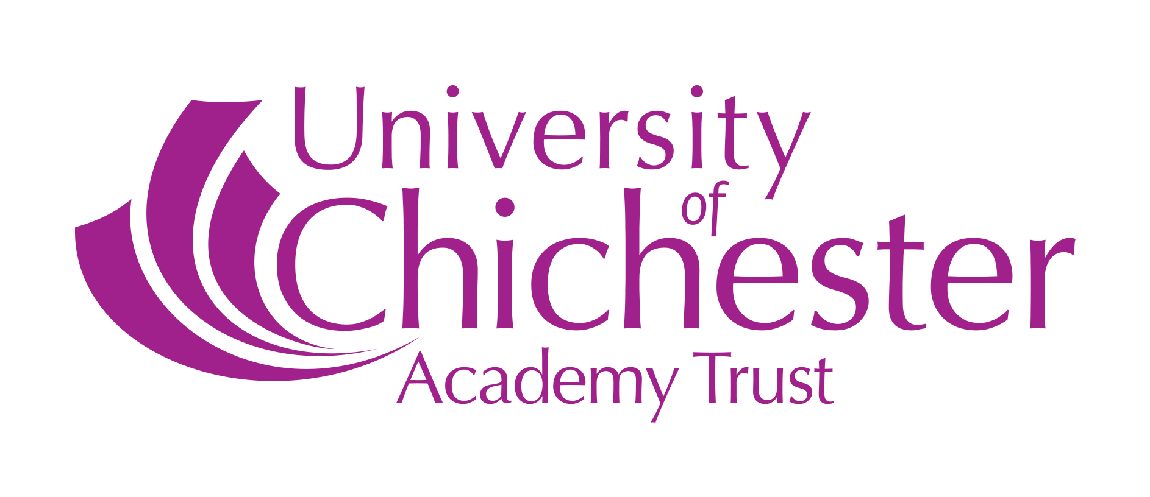
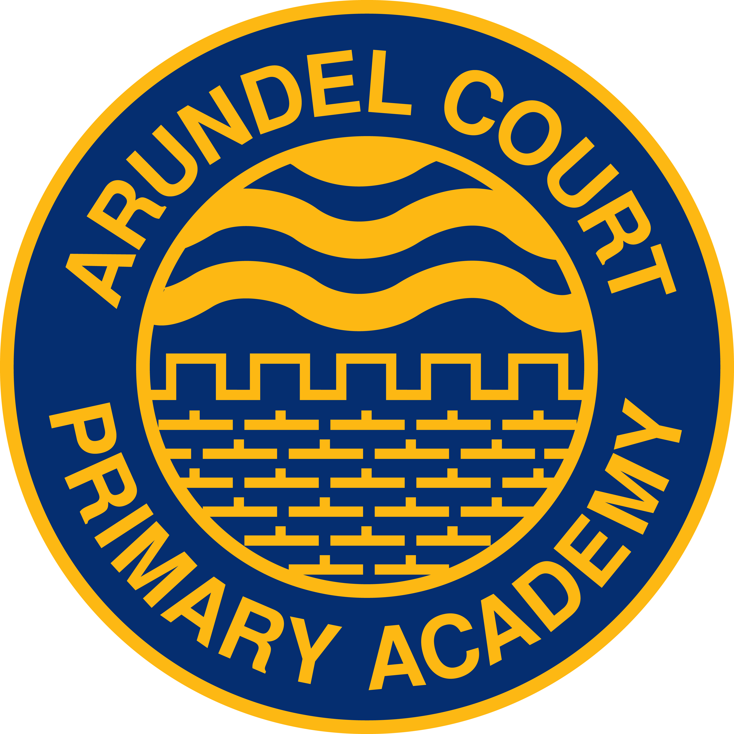

Arundel Court Phonics Statement
Children are given daily opportunities to develop their phonics and reading skills. In Nursery, pupils begin to develop their listening skills and to discriminate between sounds, recognising rhythm, rhyme and alliteration. They develop oral blending and segmenting of sounds in words. In Reception and KS1, pupils continue to have daily phonics lessons where they will learn;

- Letters are symbols (spellings) that represent sounds.
- A sound may be represented or spelled by 1,2,3 or 4 letter eg dog , street, night, dough.
- The same sound may be spelled in more than one way (one sound-different spellings) eg rain, break, gate, stay.
- Many spellings can represent more than one sound (one spelling- different sounds) eg head, seat, break.

They develop the skills of blending (combining sounds together to build words), segmenting (breaking up a word into individual sounds) and manipulating sounds to read and spell words correctly.

Phonics skills need to be taught in a consistent, systematic way. At Arundel Court Primary Academy we follow ‘Letters and Sounds’ from Foundation Stage, through KS1 and into KS2 if appropriate.
Assessment
Assessment is essential to ensure all pupils progress with phonics. In addition to discrete phonic assessments which take place at regular intervals (e.g., half termly), assessment in phonics takes place daily, where practitioners will allow opportunities to regularly assess children’s understanding. Outside the discrete daily phonics sessions there are opportunities to observe the application of phonic skills, e.g. during guided/ shared reading and application into writing.

Teachers and school leaders will monitor assessment outcomes to ensure that all children are making expected progress. This information is also used to identify children who are not making expected progress and therefore early intervention can be put in place.

Year 1 Screening Check

The Year 1 Phonics Screening Test is an informal test each child in England takes, usually in June. This is a phonics based check where children will be expected to read 40 words including nonsense (or ‘alien’) words in order to assess a child’s skills at word reading. The results will be reported to parents as well as the local authority. Children will be rechecked in Year 2 if they do not reach the expected level. If a child doesn’t meet the expected standard, we will work with them to ensure they receive the phonics teaching and support they need. The child will then retake the Phonics Screening Check the following year.

This year, due to the cancellation of all assessments in 2020/21, the pupil’s will take this assessment during the Autumn Term of Year 2. If a child doesn’t meet the expected standard, they will then be given the appropriate support with their phonics and they will retake the Phonics Screening Check in the Summer term.

Intervention/ Phonics Boosters

Through careful monitoring and tracking, teachers are able to identify children who are not making the expected progress and therefore need intervention to catch up. Depending on the needs of individuals, this may include additional individual or small group booster groups with an experienced practitioner, or extra support for a child or small group of children within a lesson.

Phonics in KS2

Children in Year 3 continue to have Phonics lessons which link carefully with their spelling programme. Phonics is such a crucial part of the children’s learning during KS1, so continuing to build on their phonics knowledge to support an understanding for spelling in KS2 can support our pupils. Additionally, if pupils in Key Stage 2 experience difficulty in reading and/or writing because they have missed or misunderstood a crucial phase of the systematic phonics teaching they will continue to be supported by trained practitioners.

Training and Monitoring

Teaching of Phonics at Arundel Court Academy is carefully monitored, with staff regularly receiving training and support to deliver phonics to a high, consistent standard. Phonics learning walks by leaders support the monitoring of pupil outcomes and consistency in teaching across the school.

Recent changes to Phonics
In April 2021, the Government published their review of the core criteria for an effective systematic synthetic phonics teaching programme and are allowing publishers to launch their own programmes to reflect the changes in the curriculum since the original publication of ‘Letters and Sounds’ in 2007. As a school, we are continuing to use ‘Letters and Sounds’, which over the years we have adapted to the needs of our pupils and the curriculum requirement.
A total of 9 systematic synthetic phonics programmes have already been validated by the DfE. A complete list of the validated phonics schemes, publishers and providers will be available by the DfE in Spring/Summer 2022 so this year we are researching already validated schemes and reflecting on current phonics teaching and assess whether it’s working, what progress children are making in phonics considering pupil outcomes, and decide the most suitable way forward.
If we feel that our current phonics provision is working for our school and pupils, then there may be no reason to change what we’re doing.
The following is the current list of validated SSP programmes:
- Bug Club Phonics
- Essential Letters and Sounds
- Floppy’s Phonics^{[footnote 1]}
- Jolly Phonics^{[footnote 1]}
- Letterland
- Little Wandle Letters and Sounds Revised
- No Nonsense Phonics
- Phonics International
- Read Write Inc.
- Reading Planet Rocket Phonics
- Sound Discovery^{[footnote 1]}
- Sounds Together^{[footnote 1]}
- Sounds-Write^{[footnote 1]}
- Success for All Phonics

