Emperor Penguins
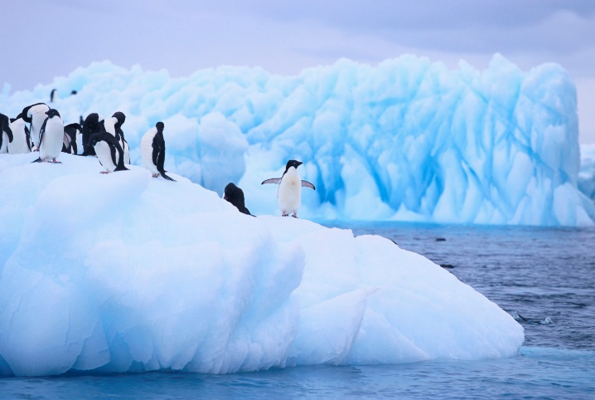
Do you want to be an expert on emperor penguins? Yes? Then read on to find out more.

Habitat
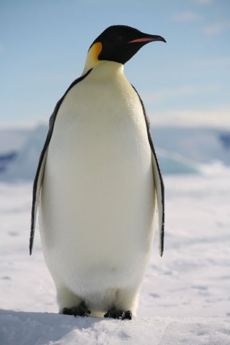
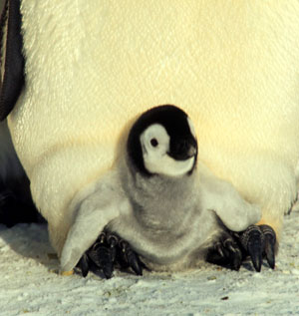
Emperor Penguins are large birds who live in Antarctica. They are warm blooded and they can survive in extremely cold temperatures. The baby starts its life on its father’s feet.

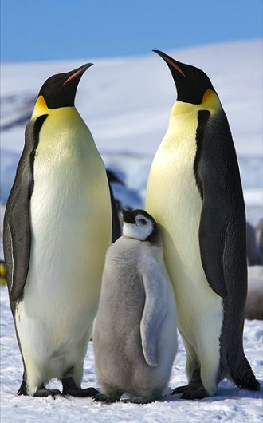
Appearance
Emperor penguins are the largest of all the penguins. They can grow up to the height of a 7 year old child. What a tall bird! Adult penguins are mainly black and white with some yellow on their necks. The babies are grey and fluffy but when they grow up their fur turns into feathers.
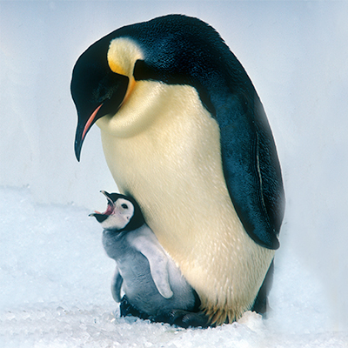
Diet
Penguins eat fish, krill and squid. Mother penguins hunt for food for their babies. Did you know, they eat their food and spit it back up into their babies mouths? How strange!

Threats
Penguins are hunted by predators like killer whales, seals and great white sharks. In some parts of Antarctica, penguins are finding it difficult to survive because there is not enough fish for them to eat. We humans need to make sure we don’t eat all their fish.
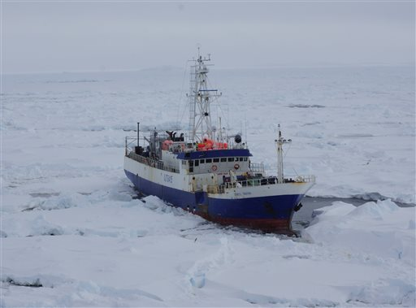

A fishing boat in Antarctica stealing all of the fish.

Emperor penguins

- Finish the sentence
Emperor penguins live in __________

- Tick the correct word to finish the sentences.

Emperor Penguins eat _______, ________ and ______ .

sweetcorn seals krill
fish sharks squid

Baby penguins are ________ and _________
pink grey
fluffy scaly

- An adjective describes a noun. Circle the 2 adjectives in this sentence.
The babies are grey and fluffy but when they grow up their fur turns into feathers.

- How tall can an emperor penguin be?
_______________________________

- Where do baby penguins live when they are fist born?

________________________________

- Jonathon says “Fishing boats in Antarctica are bad for penguins.”
Why are fishing boats bad for penguins?
_____________________________________
_____________________________________
_____________________________________

- Which of these animals hunt penguins? Tick 3.
Lions
Great white sharks
Crocodiles
Seals
Killer whales

