 | Year 1 Newsletter  Autumn 1st Half  2021-22 | 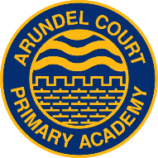
Welcome back!
The children have settled in so well and we are
looking forward to a busy and exciting term in Year 1.
Our topic this half term is ‘Animal Kingdom!’ Our ongoing topic throughout this term is ‘Autumn’.
In Science, we will be learning…  - to identify and name common animals  - to find out about different animal groups  - to find out what animals eat and use the terms ‘herbivore’, ‘omnivore’ and ‘carnivore’  - to find out about how our senses help us | 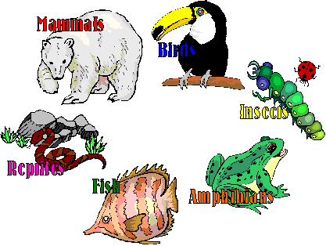We are so excited to be having a visit from the Mucky Bucket Farm at school! | In History, we will be learning...  - to find out about our own history from when we were born to now  - to find out how we have changed as we have got older

English
We will be learning…
- To read and retell nursery rhymes, ‘Monkey and Me’ by Emily Gravett and other animal stories.
- To read and spell using phonics
Phonics is a big part of Year 1. More information will follow later this term about how to support your child at home with their phonics, reading and spelling.

Maths
We will be learning...
- to count, order, read and write numbers to 20
- to add two single digit numbers
- to find out one more and one less than a number

You can support your child at home by regularly practising counting forwards and backwards.

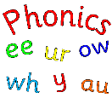

Reading Raffle!
If your child reads 4 or 5 times a week they are entered into a reading raffle. They will receive a small prize at the end of the week and entered into the half termly raffle where they can win different picture books.
Book bags need to be in school every day.
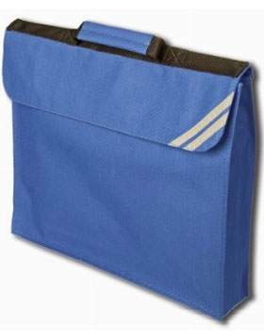
Things you can do at home!

- Share baby photos and talk about family now and in the past
- Look at different animals and discuss similarities and differences
- Practise the phonics and spellings sent home
- Practise doing and undoing zips to help with their coats.
- Practise doing up laces on shoes.

PE DAYS! W.C 6/9 20/9 4/10 18/10 – THURSDAY W.C 13/9 27/9 11/10 - FRIDAY

