Fine motor tasks

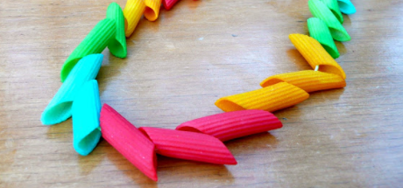Here are some quick and easy ideas that you could do at home with your child:

1. You could get your child to thread pasta onto a string and then take them off again. This activity could be repeated with other items that you have around the house including buttons and beads.

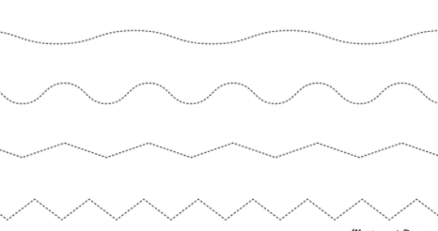

1. You can draw shapes or lines on a piece of paper and let your child cut along the lines. This will help them with their cutting skills. The lines do not have to be straight. The crazier the better.

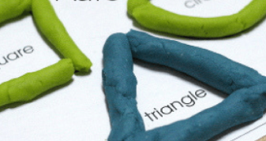

1. If you have playdoh at home, you could get your child to make different objects with them. These could include shapes, numbers and letters. You could even get them to make their name.
2. 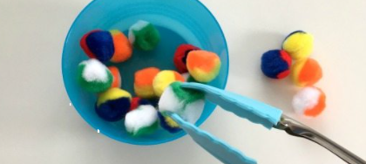If you have some tweezers at home, they could even be tongs from the kitchen, you can get your child to pick up objects and then put them into a bowl. Once they have done that, they can take them out again. Objects could include pasta, pom poms, beads or small toys.
3. 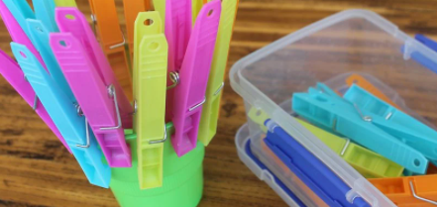For this activity your child could attach pegs to any object. These could include the edge of a cup, the edge of a plate, a lolly stick, or even some card. You could add numbers and get your child to add the correct number of pegs each time.