Arundel Court Primary Academy
Positive Behaviour Policy.

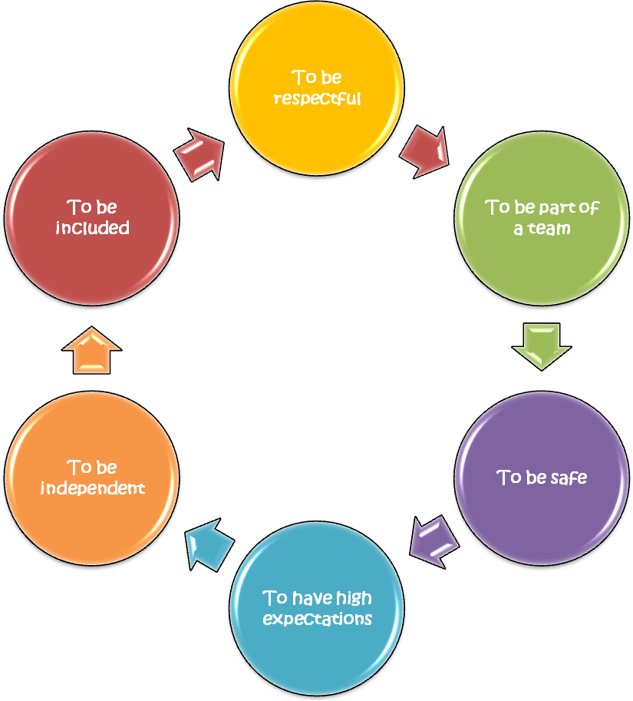


Make a difference!
Be outstanding!



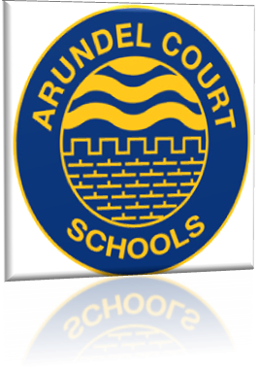
Sign up to our school’s values for
Positive Behaviour!

Make a Difference. Be Outstanding.
This policy has been developed as a result of discussions with staff, governors and the school councils. Ofsted now quality assures behaviour and if pupil’s behaviour is inadequate then this can become a limiting factor, which could put a school into a category.

Behaviour at Arundel Court has been graded as ‘Outstanding’ in our latest Ofsted inspections. (2015)

Statement of Purpose
We want all children and adults, who work in our schools to feel happy, safe and respected. Everyone in our school community is working together to make a difference in providing the right ethos and environment for this to happen. There is a joint responsibility in supporting every child to develop a positive outlook and behaviour in and out of the school community.

We believe that everyone has the right to feel safe but have the responsibility to behave in a way that lets others feel safe and happy too. Clear rules and expectations of acceptable behaviour within the schools are slightly differentiated across both schools.

Aims
- To value and appreciate one another irrespective of age, gender, creed or race and to acknowledge that everyone has a part to play within our school community.
- For all children in our care to develop self-esteem, consideration, self control, gain confidence, honesty, responsibility and respect.
- For all children to work within the golden rules and to always do the best.

ACHIEVING POSITIVE BEHAVIOUR

Parents:
- Are models for their child’s behaviour
- Will support the school, advising them of any factors at home which may effect their child’s behaviour
- Will work with the school to promote positive behaviour and resolve any difficulties, as shown in the home school agreement.

Community:
- All users of the school premises for extended activities will be given a copy of this policy.
- Regular feedback will be welcomed from visitors on the ethos and general school behaviour.

School and Class Rules
- We will regularly share our expectations with pupils, parents and the community.
- We will have clear, consistent procedures for the whole school, encouraging positive behaviour and dealing with any problems.

School and class rules are based around the golden rules & our school values. At the start of each academic year new class expectations are decided and agreed with the children, teaching assistants and class teacher. These are clearly displayed in the classroom and signed by the pupils to show their agreement and understanding. Attention is drawn to them when a rule is broken.

Golden rules

Be gentle, be kind and helpful, listen, look after property and
be honest.

Rewards

- All adults support pupils, where appropriate, by encouraging them to do their best, praising their efforts and being interested in them as individuals.
- Rewards should always be a way of acknowledging when children, as a group or individually, have achieved or accomplished more than expected.
- Exceptional behaviour can be recorded in the Bling Book and celebrated in assembly.
- Exceptional behaviour may be rewarded with a Golden sticker from the head or deputy.
- Assemblies are a good venue to celebrate exceptional behaviour.
- A house point system is used from Year 2.
- Wall of fame can also be used to showcase outstanding behaviour.
- High quality Golden Time rewards pupils from Year R to Year 2. Children in these year groups choose from a range of special activities run by staff.
- Each class may use their own reward system as designed by the class teacher e.g. table points, ‘jellybean’ moment etc.
- Happy bear system is used in all lower school classes.
- Exceptional behaviour may be recognised with a Head teachers golden badge.

Unacceptable Behaviour and consequences

If the School Rules are broken, we have established a clear system of sanctions, which are known by the children, staff and parents. (See overleaf)

WARNING

Reminder of
Expectations e.g.
Golden Rules
STAGE 1
Minor poking, interrupting, irritating others, talking, annoying, non-compliance to Golden Rules, walking around classroom, making silly noises.
STAGE 2
Repetition of Stage 1
E.g. Cheeky, arrogance, back chatting, minor disturbances, low level offences.
Lower: Child moves name to ‘iffy’ bear

Upper: name on board
STAGE 3
Stages1 & 2 repeated
Verbal aggression
Ignoring instructions, defiant body language and refusals.

Lower: child moves name to sad bear, loses 5 mins GT.
Upper: child sent to another class with work (20 mins)

STAGE 4
Stages1, 2 and 3 repeated
Verbal aggression
Ignoring instructions, defiant body language and refusals.

Teacher initiated behaviour / reward system put in place in class and inform the inclusion team and parents.

STAGE 5
Failed behaviour / reward system or consistent destructive behaviour, verbal aggression, extreme rudeness, spitting, minor physical, stealing, swearing, vandalism.
Lower: Time out -
red card and swap class.
Upper: lunch time detention and parental involvement.

Possible report and inclusion action plan.

STAGE 6
Extreme violence
Injuries, serious damage to property
Out of control.

Consistent and ongoing poor behaviour from stages 3 or 4.

Internal or external exclusion
Possible visit from PCSO/Police

(Upper) Children should be sent to the following year groups:-
Y6 to Y4
Y5 to Y3
Y4 to Y6
Y3 to Y5

- Detention may also be used for a further sanction. (see attachment on detention) Upper only

- Concerning behaviours will be recorded on our in school tracking system.

- If the behaviour of a child fails to improve, he/she will be placed on a daily report which will usually be sent home.

- If a child is having regular or serious behavioural difficulties, the class teacher will involve the Deputy and/or the Headteacher. The child’s parents may be consulted by a member of staff at any stage of the discipline procedure so that home and school can work together to support the child.

- There are further sanctions that can be applied by the Headteacher, including temporary or permanent exclusions.

Lunchtimes
- All midday assistants are encouraged to be positive with every child and praise and encourage good behaviour. All staff are expected to follow the aims of both schools to help make the lunchtime experience a happy and safe one.
- House points maybe used in the upper school.
- However, when concerning behaviour occurs, a five minute “time out” period will be used. Upper only.
- A child may be excluded from school during lunchtime for persistent misbehaviour and parents will be informed.

Dear Parent/ Carer

We believe a calm learning environment can be achieved only when there are clear rules, rewards and consequences. It is also important that we have the support of parents.

Our policy also concentrates on that everyone within our school community signs up to and agrees with our core values as can be seen on the front page.

Children who follow these rules and values will receive:
- All adults support pupils, where appropriate, by encouraging them to do their best, praising their efforts and being interested in them as individuals.
- Rewards should always be a way of acknowledging when children, as a group or individually, have achieved or accomplished more than expected.
- Exceptional behaviour can be recorded in the Bling Book and celebrated in assembly.
- Exceptional behaviour may be rewarded with a Golden sticker from the head or deputy.
- Assemblies are a good venue to celebrate exceptional behaviour.
- A house point system is used from Year 2.
- Wall of fame can also be used to showcase outstanding behaviour.
- High quality Golden Time rewards pupils from Year R to Year 2. Children in these year groups choose from a range of special activities run by staff.
- Each class may use their own reward system as designed by the class teacher e.g. table points, ‘jellybean’ moment etc.
- Happy bear system is used in all lower school classes.
- Exceptional behaviour may be recognised with a Head teachers golden badge.

Unacceptable Behaviour and consequences
If the School Rules are broken, we have established a clear system of sanctions, which are known by the children, staff and parents. (See inside booklet).

We ask that parents support the schools by completing the slip below.

Yours sincerely

Ms K Stocks
Headteacher
…………………………………………………………………………………………

I have read the rules of behaviour and agree to support the school by ensuring that my child knows and follows these rules.

Child’s Name:…………………………………………… Class:………………………..

Signed:……………………………………………….Parent/Guardian

Detention at Arundel Court Primary Academy

Where and When?

Detention will take place during LUNCHTIME with a senior member of staff.

It will last for 45 minutes and will be overseen by a senior member of staff.

Children will enter the room and will be told to sit in complete silence.

They need to bring their lunch with them and collect their school dinners at the start of lunch.

Teachers should ensure that the pupil(s) are brought down to the detention room.

The children should bring with them a detention slip explaining briefly why they are in detention.

What are the criteria for a child receiving detention?

Detention should be given out to a child as a last resort.
e.g. Fighting or swearing merits a detention.

However it is up to teacher’s discretion. At the same time it needs to be an effective use of punishment that children will not want to receive.

The less detention is used the more effective it becomes.

What next?

Children who receive detention will have their parents/carers informed and they may be asked to make an appointment with the school to discuss their child’s behaviour.

They may be put on report.

Review October 2020

