English – Summer poetry.
Day 1
Before writing our ‘Summer Poem’ we need to collect a bank of ideas and powerful imagery to use.

Create yourself a mind map just like the one below. If you want to change any of the headings, then please feel free to do so.
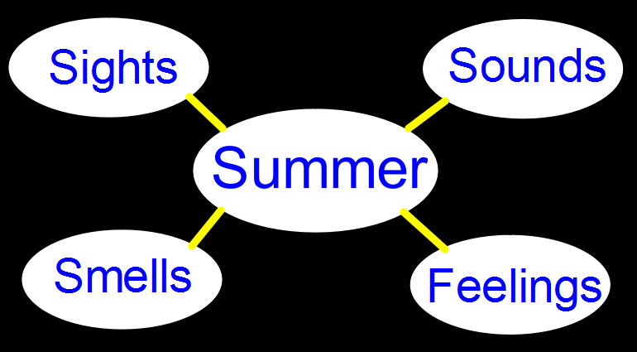

Once you’ve created your mind map start adding ideas that you can use in your poem, focus on using key words instead of sentences and try to write from personal experience (see below).
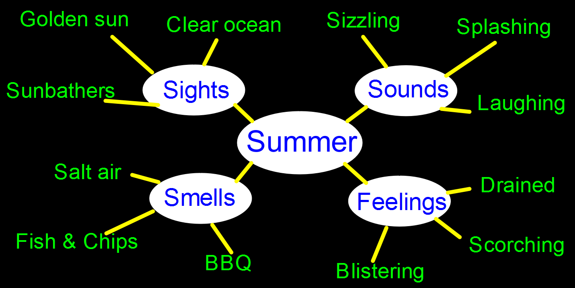

Aim to spend half an hour on this activity and try to add as many words as you can think of, remember that you can use online dictionaries and thesauruses to help generate powerful vocabulary.
Day 2
MAKE SURE YOU HAVE YOUR PLAN FROM YESTERDAY!
Using the ideas in your plan, start to create lines of poetry. Do not worry about making them perfect (yet), if an idea pops into your head then simply write it down (see below).
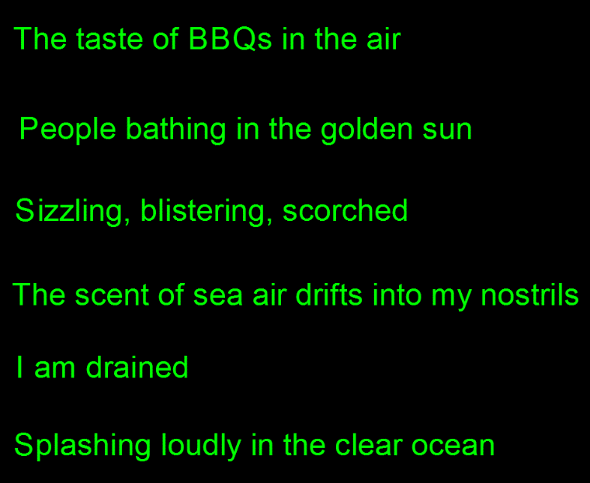

Once you’ve generated around six lines we need to edit them, try to get rid of words like ‘and’ or ‘the,’ also try to improve upon the vocabulary (see below).
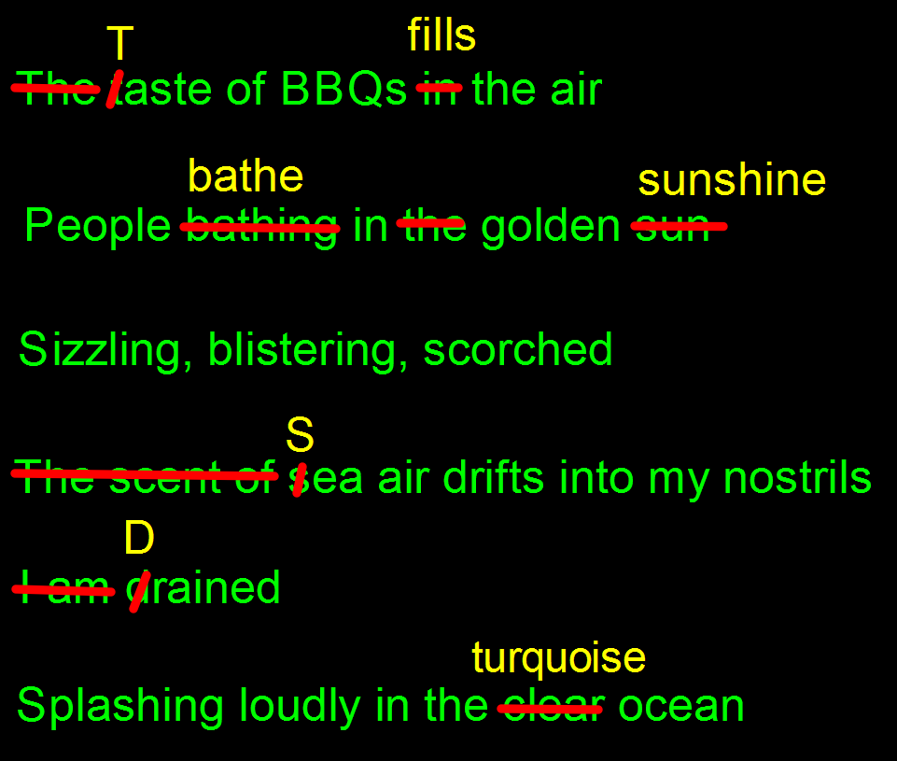

My final edited version now reads like this:
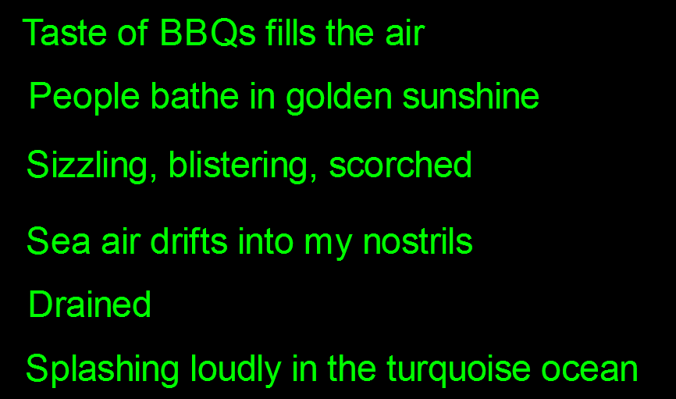

The final stage is to think about re-ordering your lines to generate a better impact for the reader. I’ve literally just experimented with putting different lines in different places until I found a stanza that I was happy with (see below).
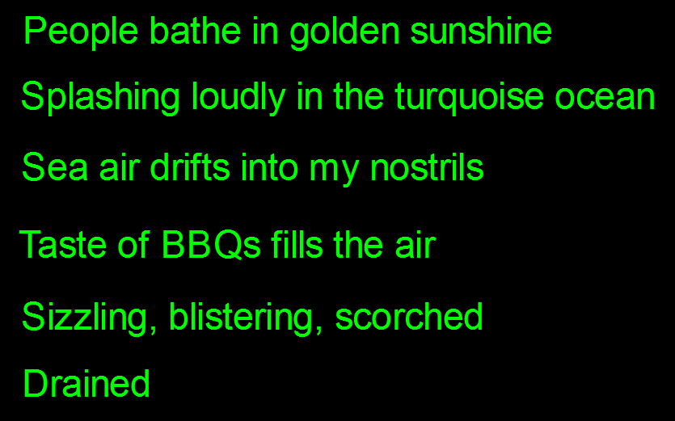

So, your task is to create one stanza of poetry that uses your plan from yesterday. Follow the steps that I have provided and aim to spend around 45 minutes on this task. Feel free to add more ideas to your plan if they pop into your head because you can use them tomorrow.

Day 3
Today I want you to create a second stanza of poetry. Follow the exact same process as yesterday.

Once you have finished your second stanza you need to try and think of a title for your poem.

Again, it should take you around 45 minutes to complete this task.

Day 4
If you want to create a third stanza of poetry, then please feel free.

Otherwise – IT’S PERFORMANCE TIME!

When you perform you need to think about raising and lowering your voice to emphasise certain parts of the poem, if you have a sibling then get them to perform it with you. You can add drama, actions, music or sound effects. The choice is yours.

Be brave, be loud and perform your poem with confidence. If you have a cat or a dog then perform it to them, if you’re feeling really brave then bellow it out in the garden or out of your window for all to hear!

Aim to spend around 20 minutes getting ready for the performance and then go for it. Try recording yourself on your phone and watch it back to see if you can improve it further. Good luck!

