Supporting your child: Allow your child to have a go at reading this information leaflet. If they find it too tricky read it to them and answer the questions at the end together.
Emperor Penguins
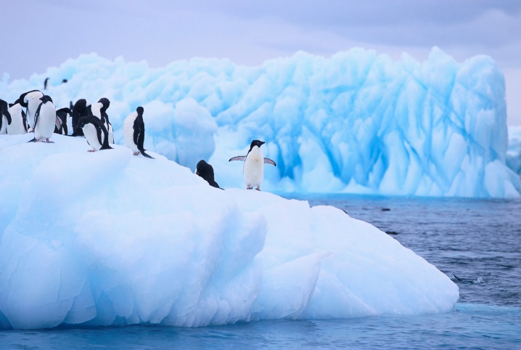
Do you want to be an expert on emperor penguins? Yes? Then read on to find out more.

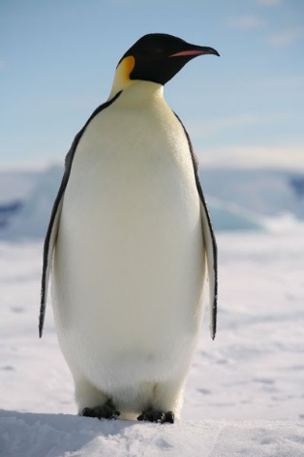
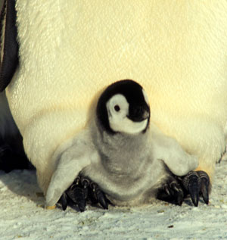
Where do they live?
Emperor Penguins are large birds who live in Antarctica. Antarctica is a very cold place.

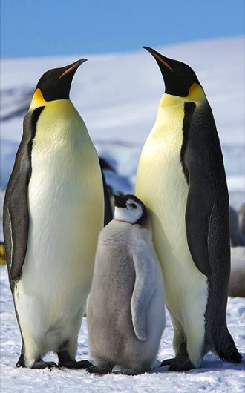
What do they look like?
Emperor penguins are large. They are as large as a 7 year old child. What a tall bird! Adults are black, white, yellow and orange. Babies are grey and fluffy.
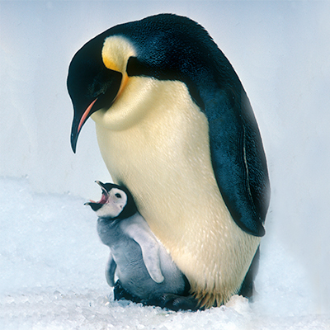
What do they eat?
Penguins eat fish, krill and squid. Mother penguins spit food into babies mouths. How strange!

Questions
- Where do emperor penguins live?
___________________________
- Is Antarctica a hot place or a cold place?
______________________________
- What colours is an adult penguin?
_______________________________
- What does a baby penguin look like?

__________________________________
- What do penguins eat?
____________________________________

