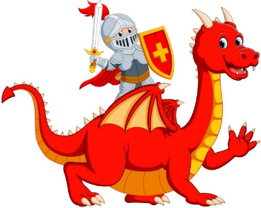

**School Trips**

We are hoping to be visiting Arundel Castle this half term as part of our Dungeons and Dragons topic. We will also be hosting a medieval day in school.

**RE**

This term, Harvest falls on October 3rd. Therefore, in RE we are looking at Bread as a Symbol.

**Music**

We will be using our Charanga programme to teach the children a wide range of music styles such as listening, singing, playing, composing and performing.

 Our music will be based around the topic of making friends.

**Art**

We are looking at the work of the artist Paul Klee and using materials to recreate his artwork. We will be learning to develop skills and techniques in using colour, line, shape, and space.

**Maths**

We are learning about place value and the position (place) of a digit in a number determines its value. We will identify, represent and estimate numbers using different representations including the number line. We will be using our skills to solve problems.

We will compare and order numbers from 0 up to 100; use <, > and = signs.

Counting Focus

Our counting focus this half term is counting forwards and backwards in 2’s,5’s and 10s.

We will start to rote learn the 10 x table.

**English**

Composition – We will be writing about real events and create pieces such as recounts, instructions and information leaflets all around our topic.

Handwriting – We are focussing on formation and orientation of letters. We will look at capital letters and their relationship to lowercase letters.

Vocabulary, Punctuation and Grammar – We will learn about using of capital letters and full stops, listing commas and how to use conjunctions.

Spelling – We will be starting a new spelling programme in Year 2 and the children will be sent home weekly spellings to learn at home. Children will be learning how to spell high frequency words, common exception words as well as learning spelling rules.

**PE**

In PE we will be using our Jasmine PE scheme. We will be getting the wall bars out, learning basic gym shapes and developing our balance, agility and coordination.

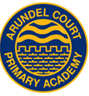

The children have settled in really well into their new classes and we are excited to get learning. Please remember to provide your child with suitable footwear for outdoor PE.

Year 2 Curriculum News

**PSHE**

Our PSHE unit this half term is Being Me in my World. We will be settling the children into year 2 talking about our hopes and fears for the year.

We will talk about rewards and consequences as well as our rights and responsibilities.

**Dungeons and Dragons**

**Autumn 1 2021**

**Science**

We are learning about animals including humans. In this topic we will notice that animals have offspring and describe the importance of exercise and a balanced diet.

**History**

We are looking at the Medieval Period and discussing the similarities and differences to life then and now. We will also be looking at timelines and discussing where different events fit into a chronological narrative. We will be looking at types of castles and writing about the different features and their uses.

**Reading** This year Arundel Court aims to become a school that reads! Children should be picking up a text to read for enjoyment or pleasure. This will be encouraged at school and it would be wonderful if it could be continued at home. The children will be receiving a home reading record this half term which they can use to record their reading at home. 4x reads a week gets a ticket into our Reading Raffle which is held half termly. This will not only help their reading but also have an impact on their writing.

**Computing**

We are researchers

We will be learning about computing systems and networks. We will be looking at what IT is, where we see it in our daily lives and also how to keep safe while online.