Maths- Summer
Day 1-
Head to TT Rock stars https://play.ttrockstars.com/auth/school/teacher and spend some time practising your times tables and climbing the leader board Then, attempt your magnificent multiplication test. Provided are the tests. Feel free to work through these whenever you are bored at home, or fancy a challenge. Why don’t you take on your parent, carer or sibling? Aim for the stars – good luck!
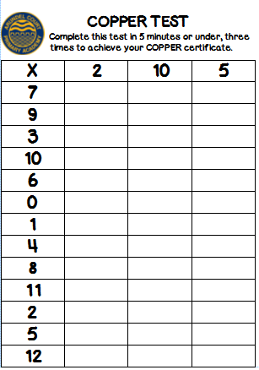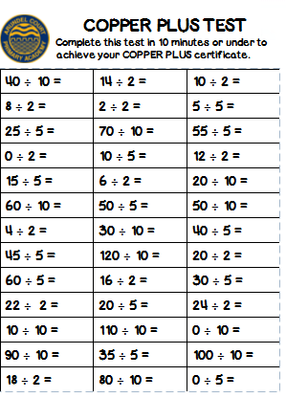
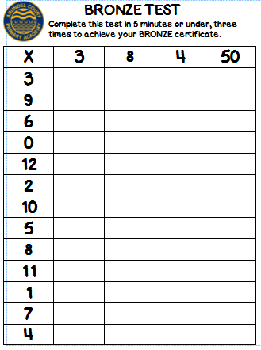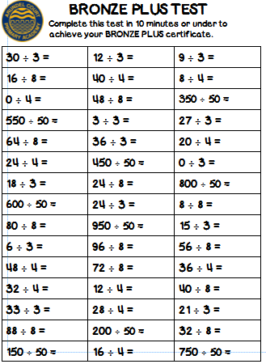
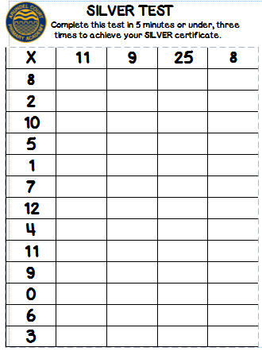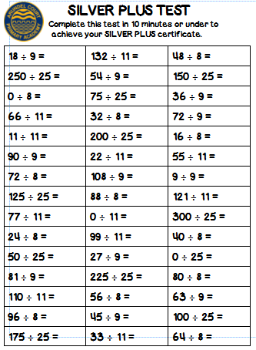
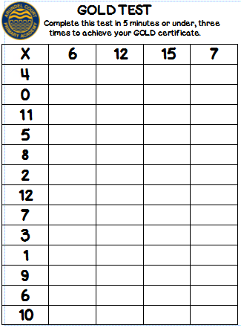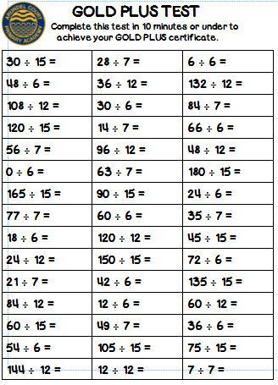

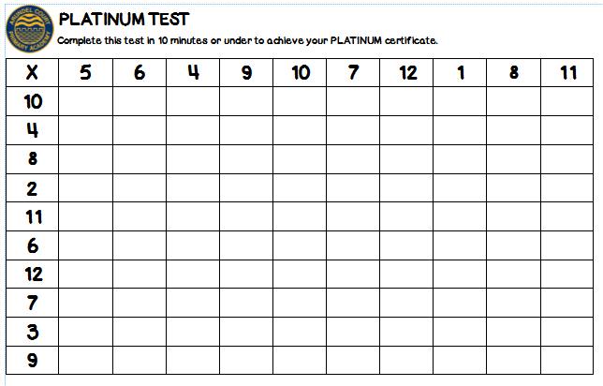
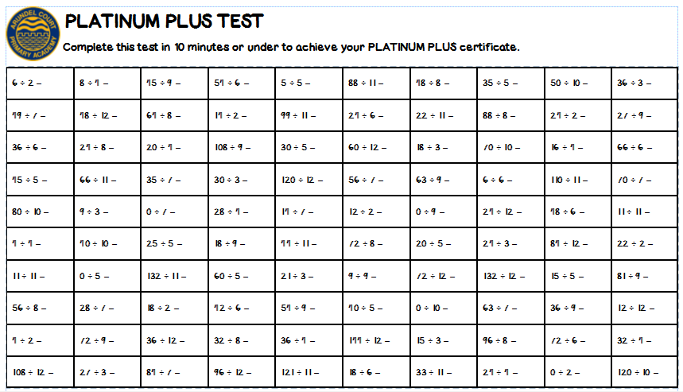
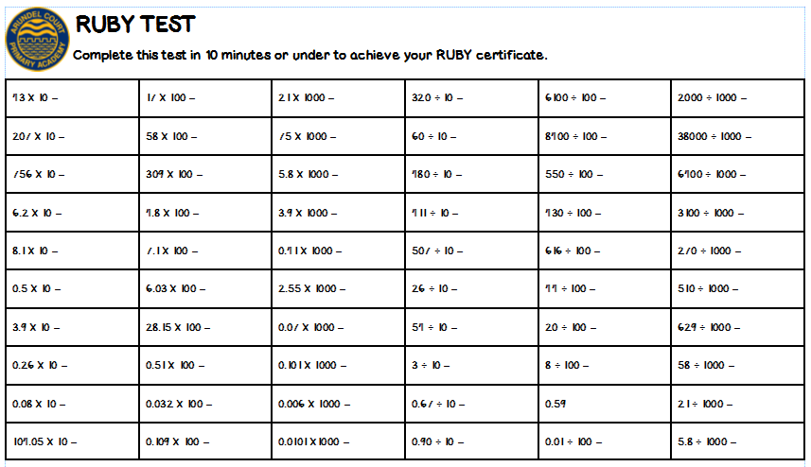
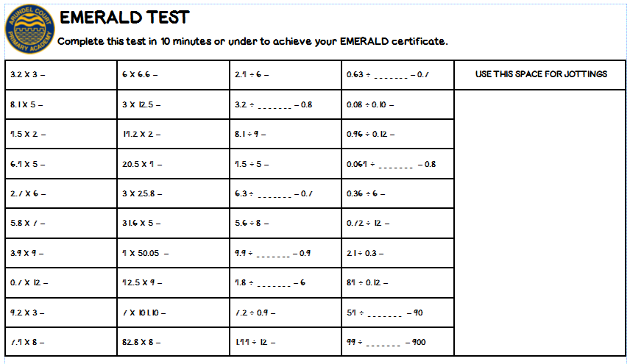

Day 2-
Work through the place value activity sheet below. What is the value of the underlined digit?
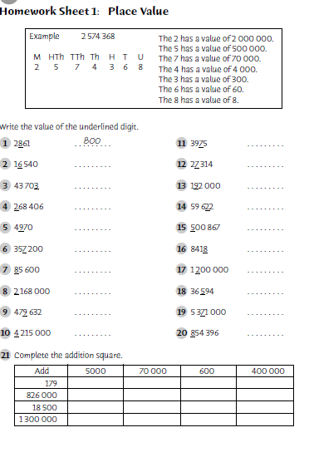
Day 3-
Today we would like you to have another look at place value. Think about the activity that you completed yesterday and work through the questions below. You might want to copy and complete the questions on paper.
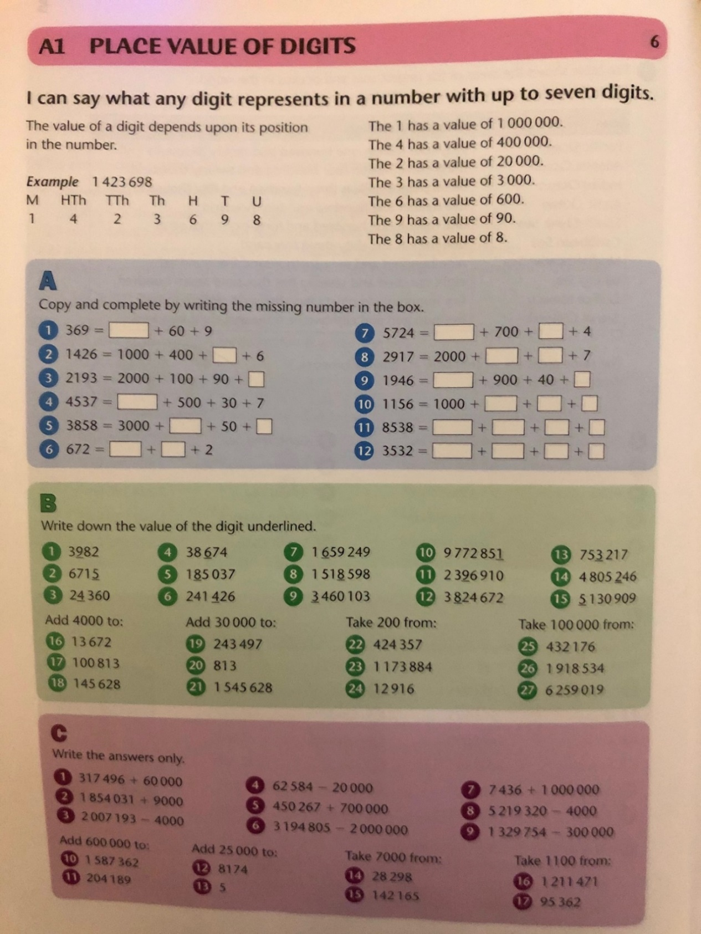

Day 4-
Visit this website https://www.topmarks.co.uk/maths-games/7-11-years/ordering-and-sequencing-numbers and play games from the place value and ordering sequences of numbers sections.
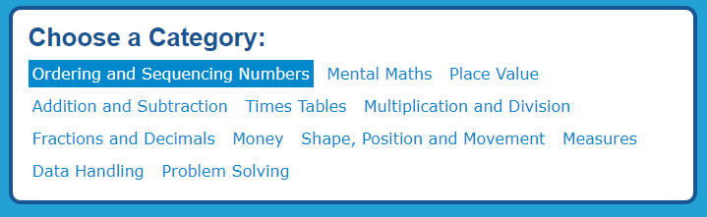
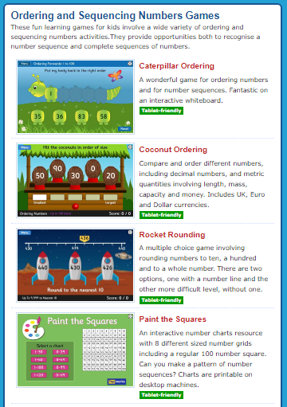

Task 5-
Below is a BBC Bitesize video for you to watch all about multiplying and dividing by 10, 100 and 1000. Watch the video and then have a go at the questions below.
https://www.bbc.co.uk/bitesize/topics/z36tyrd/articles/zd9cydm

