Reception Autumn 1st Half Term Curriculum Newsletter 2021-2022
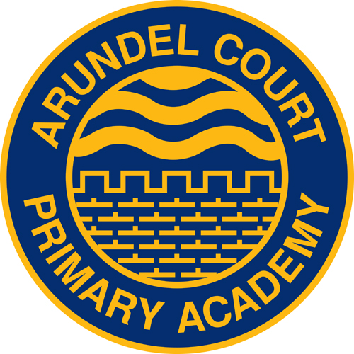

Reception Topics: Being me in my world!

Topic overview: In the Autumn 1st Half the children will be introduced to our class and school routines. The children will start to look closely at similarities and differences between themselves and others.

How can you help

Talk to your child about Reception routines.
(A planned routine attached.)
Share a book together and discuss the story.
Point out numbers up to 10 with your children and practice counting out that amount.

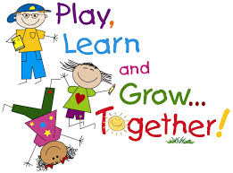
Ask your child about our Reception rules.
Behaviour chart
Super Happy
Happy
Iffy
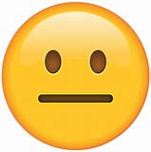

Sad

We will be exploring labels around us. Why not see how many labels you can spot on the way to school.

Ask your child to draw a picture. Can they talk about their picture?
Encourage independence

Getting dressed

Preparing for lunch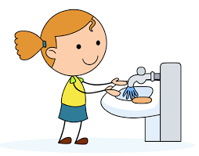

Using a knife and fork with their dinner.

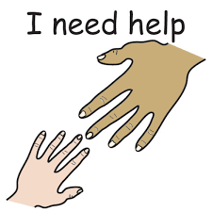Ask for help!

Ask your child about their day,
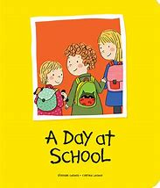

If you have any questions about this topic or on how to support your child further, please speak to your child’s teacher.

Reception Timetable

9am | 9-9:15am | 9:15-10:10am | 10:10-10:30am | 10:30-11:10am | 11:10-11:20am | 11:30-12:15
Start school | Welcome time.  What are we doing today? | Phonics  and reading | Playtime | Maths | Calming down and get ready for lunch. | Lunchtime
12:15-1:15 | 1:20-1:40 | 1:40-2pm | 2-3pm | 3pm
Relaxation and Big Question | Playtime | Fine motor skills | Plan, do , review | Home time

PE in Reception is on a Wednesday.
Please can your child come in dressed in their PE kit.

Reception Autumn 1st Half Knowledge Organisers
Topic: Being me in my world

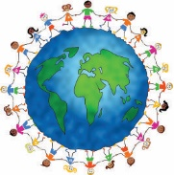
Key Vocabulary:

- Teacher
- Arundel Court
- Portsmouth
- Rules
- Happy
- Sad
- Angry
- worried
- Excited
- Surprised
- Scared
- Frustrated
- confused
- Head
- Body
- Legs
- Hands
- Face
- Eyes
- Ears
- Nose
- Mouth
- Fingers
- Toes
- Colours
- Red
- Green
- Blue
- Yellow
- Number
- Letter
- Similarities
- Differences
- Seasons
- Autumn
- Observation
- Material
- Explore
- Wash hands

Understanding the World
Basic Knowledge:
I know some differences and similarities between myself and others.
I know the names of the seasons and days of the week.
I can talk about the world around me.
I go to Arundel Court School.
My class name is…
I know I have to follow reception rules to make my friends happy and for me to be happy to.

Expressive Arts & Design
Basic Knowledge:
Exploring different equipment in the classroom to write with (pencils, crayons etc)
Find and use resources to make art work.
Use their knowledge of media, colours and different features of their body to create a self-portrait.
Sing songs and rhymes about ourselves and bodies.

Physical Development
Basic Knowledge:

Move safely in different direction in a variety of way.

Use of different apparatus and equipment.

Start developing correct pencil grip.

